# Polymer chainPolymers

# Basic Terminology

|  |  |
| --- | --- |
| Term | Definition |
| polymer | A broad class of materials made up of long molecules, each molecule made up of repeated molecular building blocks. |
| polymer chain | An alternative term for a polymer molecule, it usually refers to the monomer units along the length of the molecule rather than the branches. |
| monomer | A molecule that is used to synthesise a polymer chain. |
| monomer unit | The repeated building blocks that make up a polymer chain (it may consist of more than one monomer). |
| polymerisation | The process of synthesising a polymer. |
| addition polymerisation | A process for synthesising polymers involving monomers with double or triple carbon-carbon bonds. During the process, single bonds are formed between neighbouring monomers to create the polymer chain. |
| condensation polymerisation | A process of polymerisation that involves monomers with two functional groups, one on each end. The monomers are joined by chemical reactions between functional groups. Smaller molecules, such as water or hydrogen chloride, are also produced during the reaction. |
| plastic | A material made of polymers that can be moulded or shaped. |

# Example Diagrams:

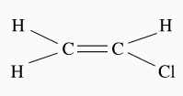

monomer (chloroethene) monomer unit polymer (polychloroethene)

# Naming and Formula

* Polymers are named after the monomer they form from. For example, if the polymer is made from multiples of the monomer ethene, it is called polyethene.
* The chemical formula for a polymer is written as one monomer unit inside square brackets. Outside the brackets is a subscript *n*, which indicates that the monomer unit is repeated *n* times along the chain. In most cases, *n* varies from one chain to another in the polymer sample and is not specified.

For example, the chemical formula for polychloroethene is:

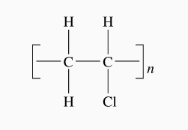

Polymer Chemical Formula

# Physical Properties of Polymers

The physical properties of a polymer are determined by:

* the type of monomers used to create the polymer.
* the length (and therefore molecular mass) of the polymer molecules.
* how the polymer molecules are bonded to each other.

Polymers have three basic structures. These are:

* [straight-chain polymers](http://lightbook.pearsonplaces.com.au/CH12_WA/units/CH12_WA-U04/chapters/CH12_WA-U04-12/modules/CH12_WA-U04-12-01/pages/Psec04172015154312682408/topics/Tsec06262015160835773870#sec06012015115210465701)
* [branched polymers](http://lightbook.pearsonplaces.com.au/CH12_WA/units/CH12_WA-U04/chapters/CH12_WA-U04-12/modules/CH12_WA-U04-12-01/pages/Psec04172015154312682408/topics/Tsec06262015160835773870#sec06012015115201425522)
* [cross-linked polymers](http://lightbook.pearsonplaces.com.au/CH12_WA/units/CH12_WA-U04/chapters/CH12_WA-U04-12/modules/CH12_WA-U04-12-01/pages/Psec04172015154312682408/topics/Tsec06262015160835773870#sec06012015115203682408).

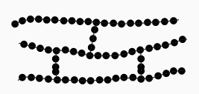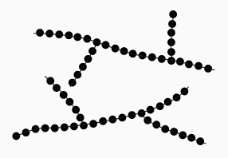

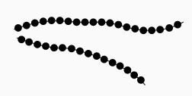

**Straight-chain Branched Cross-linked**

# Types of Polymer Materials

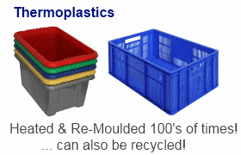**Thermoplastic (thermosoftening plastic)** is a polymer that can easily melt into a liquid and be moulded into shapes. They can be melted and recast many times and are easily recyclable. Straight-chain polymers are usually thermoplastics.

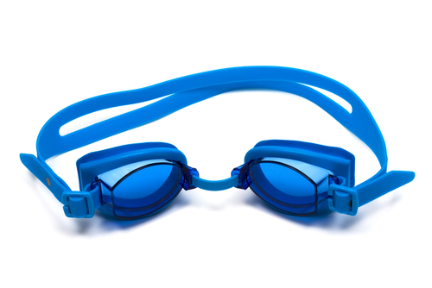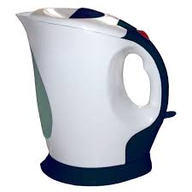**Thermosetting plastics** are liquid or soft polymers that are malleable at low temperatures but change irreversibly to become hard at high temperatures. The setting process is due to the formation of extensive cross-linked polymers. Once hard, these polymers cannot be melted into a liquid and recast. Thermosetting plastics are generally stronger than thermoplastic materials due to the 3D network of bonds (cross-linking) and are also better suited to high-temperature applications as they are less likely to melt. However, they are more brittle and are generally not recycled.

**Elastomers** are polymers with elastic properties due to a small proportion of cross-linking.



Polymers with few branches are very compact, and the chains can thus pack together very efficiently. These polymers tend to have a very high density. Since the chains are tightly packed, the dispersion forces between the chains are strong, and these polymers tend to be stronger and more rigid.

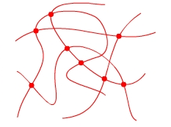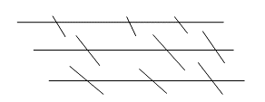Polymers that are highly branched cannot pack together as well, and there tend to be large spaces in the structure. These polymers have a much lower density. Since the chains are not tightly packed, the dispersion force between the chains is weaker, and these polymers tend to be weaker and softer.

Polymers with a high degree of cross-linking cannot be liquids because the polymer chains are held in place by the cross-linking and cannot flow.

# Addition Polymers

* Requires unsaturated monomers (monomers containing a double bond).

**Addition Reaction:**

A reaction in which double bonds are broken as molecules combine to form the polymer. No other products forms

* During the polymerisation process, the double bonds between the monomers are broken, and single covalent bonds are formed. Only one product results from this process.

**Addition Polymer Examples:**

**polychloroethene (PVC–vinyl chloride is a non-IUPAC name for chloroethene)**

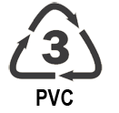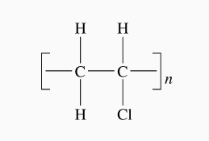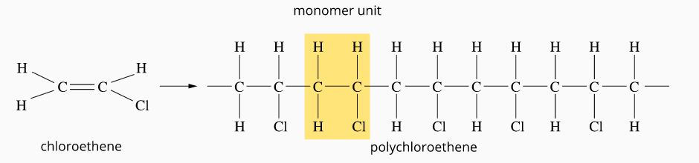

PVC is often used for garbage bags, hoses, pipes, raincoats

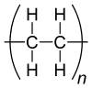**polyethene (PE)**

There are two types of polyethene: low-density polyethene (LDPE) and high-density polyethene (HDPE).

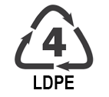**Low-density polyethene (LDPE)**

* Formed at high temperatures (≈500∘C) in a process called “free radicle polymerisation”
* This process causes significant branching, resulting in a loosely packed, low-density, soft, transparent, and flexible material. Many uses include plastic bags and cling wrap.

**High-density polyethene (HDPE)**

* 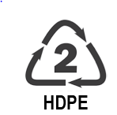It is formed at lower temperatures by using a catalyst. The catalyst breaks the double bonds in the ethene monomers to start the polymerisation reaction.
* It is almost completely unbranched. These chains can pack together tightly, and the resulting material is opaque, more rigid, and stronger, with a higher melting point than LDPE. It is used in many plastic containers.

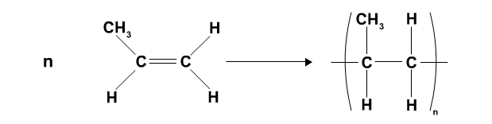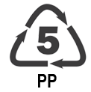**polypropene (PP)**

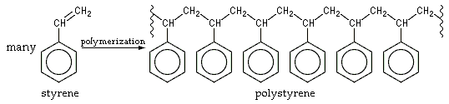

**polystyrene (PS)**

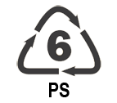

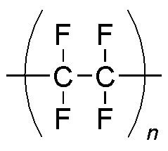**polytetrafluoroethene (PTFE) – Teflon (brand name)**

* Teflon has exceptional properties that make it useful for various specific applications, such as non-slip surfaces on cookware.

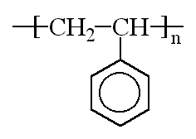**Properties of Addition Polymers**

Addition polymers are long-chain molecules that are saturated and non-polar. Their structure results in their having several characteristic properties:

1. Since the hydrocarbon chains are often exceptionally long, their intermolecular forces are often very strong, and the polymers have relatively high melting and boiling points.
2. Since the chains are nonpolar, addition polymers are insoluble in water. However, since the chains are long (strong intermolecular forces) and often tangled, they are also generally insoluble in nonpolar solvents.
3. Their low reactivity means that they are not easily decomposed in nature and, as a result, have an exceedingly long lifetime. Such substances are considered non-biodegradable and constitute an environmental hazard as they are very persistent in nature and, thus, challenging to dispose of.
4. Addition polymers are generally linear or branched with little cross-linking. As a result, they are thermoplastic materials, which flow easily when heated and can be moulded into various shapes. This makes them readily recycled.
5. The density and strength of addition polymers vary widely. They mainly depend on the nature and extent of the chain's branching.

**Condensation Polymerisation**

A **condensation reaction** is a chemical reaction in which two molecules combine to form a larger molecule, together with the loss of a small molecule.

Addition polymerisation is limited to the use of unsaturated monomers. Chemists use a second technique, condensation polymerisation, to obtain an even broader range of polymers. Unlike addition polymers, condensation polymers contain double bonds but not on the main chain, resulting in low biodegradability for most synthetic condensation polymers.

**Main Points:**

* Condensation polymerisation is a process that involves monomers with two functional groups, one on each end.
* The monomers are joined through chemical reactions between the functional groups on the end of neighbouring monomers.
* Some atoms are removed from the monomers, forming small neutral molecules such as water or hydrogen chloride.
* Condensation polymerisation usually involves two different monomers that combine to form the monomer unit. (See the diagram below).

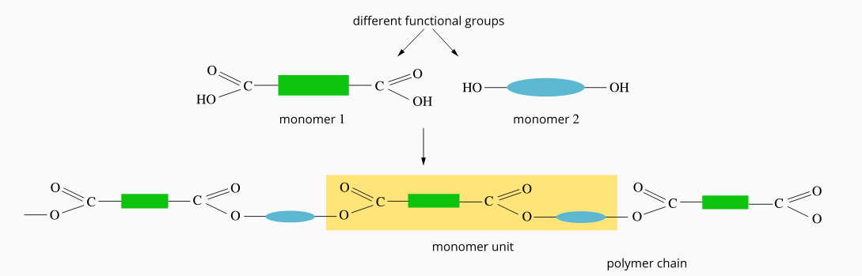

A condensation polymer forming from two different monomer units

**Condensation Polymer Examples**

**There are many types of condensation polymers. Two common groups include:**

* Polyesters (e.g. PET, used in recyclable drink bottles)
* Polyamides (e.g. nylon, used in stockings and Kevlar, used in bulletproof vests)

# **https://o.quizlet.com/i/6HGq-FdgNVByySiw-JmpUg_m.jpgPolyesters**

In chemistry, polyester is a family of polymers formed by condensation polymerisation. The polymerisation reaction results in polymers that contain the ester functional group (see diagram to the right) in their main chain.

As shown below, polyesters combine dicarboxylic acid monomers and diol monomers. A diol is an alcohol with two hydroxyl (–OH) groups.

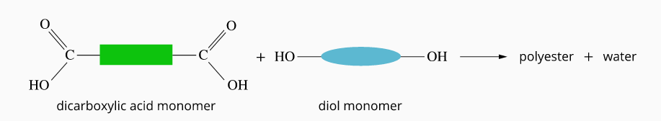

The condensation polymerisation process only adds monomers to the end of the chain. Therefore branching is negligible. As the chain grows, it is less likely that the monomer hits the end, so growth eventually slows and stops.

**Polyethylene terephthalate (PET)**

**Drawing the Monomer Unit for Polyesters**

To draw the monomer unit, remove the hydroxyl groups from the dicarboxylic acid and the hydrogen atoms from the hydroxyl groups of the diol. Then join the remaining segments together.

Monomer units can be joined together if you need to draw a section of the polymer

PET is a commonly used polyester used to make fabrics and plastic bottles. Like other polyesters, it is produced from the condensation reaction between a dicarboxylic acid and a diol.

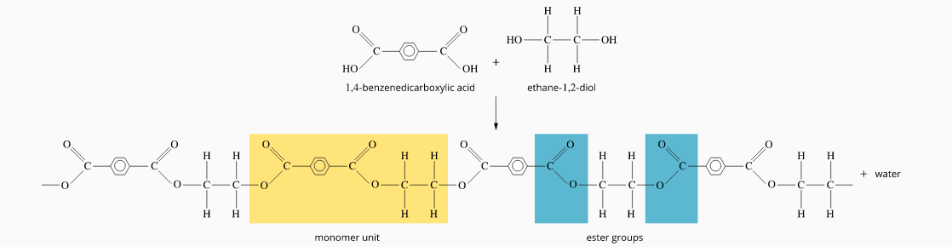

# **Polyamides**

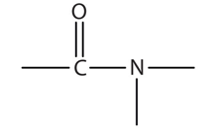In chemistry, polyamide is a family of polymers formed by condensation polymerisation. The polymerisation reaction results in polymers that contain the amide functional group (see diagram to the right) in their main chain.

Polyamides form when dicarboxylic acid molecules react with diamine molecules.

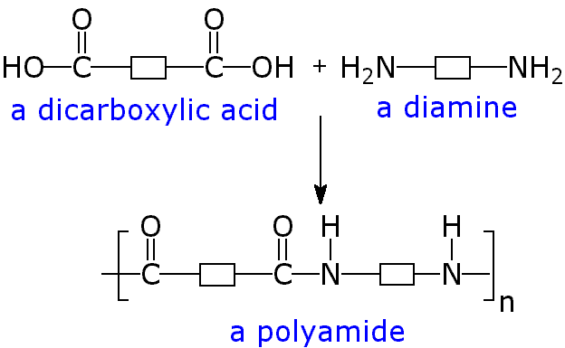

**Nylon**

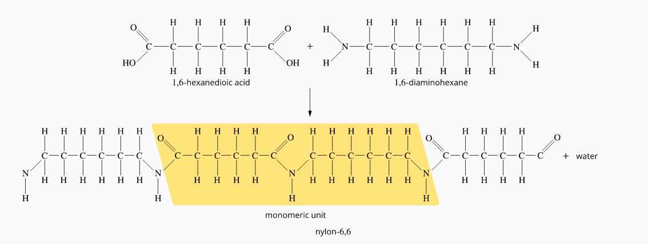Nylon is a typical example of a polyamide. Nylon can be easily drawn into fibres with a high tensile strength. Nylon refers to a group of polyamides in which the monomers contain linear carbon chains.

**Kevlar**

Replacing the carbon chains in nylon with benzene rings produces the polymer known as Kevlar.

**Drawing the Monomer unit for Polyamides**

To draw the monomer unit, remove the hydroxyl groups from the dicarboxylic acid and one of the hydrogen atoms from the amine groups of the diamine. Then join the remaining segments together.

Monomer units can be joined together if you need to draw a section of the polymer

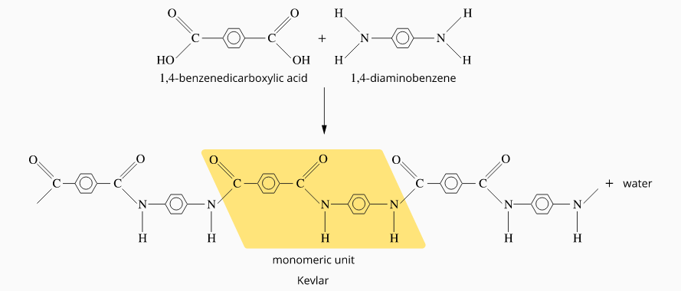

Kevlar is an extremely strong material that is also very lightweight. This makes Kevlar particularly useful in a range of applications requiring extreme strength, such as bulletproof vests and anchor cables.

The structure of nylon and Kevlar allows the molecules to align closely together. As a result, there is strong hydrogen bonding between the amide groups in these molecules. Kevlar is stiffer than nylon due to the benzene rings.

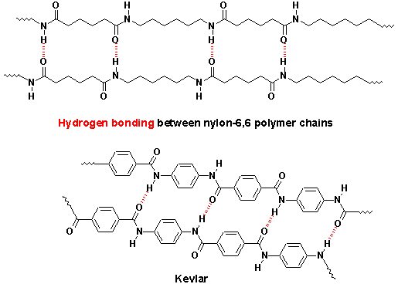

**Properties of Condensation Polymers**

* Condensation polymers tend to consist mainly of straight chains with few branches.
* Since there are few branches in condensation polymers, they are usually linear and can thus pack closely together. Condensation polymers, therefore, have a higher tensile strength than addition polymers. Polyamides and polyesters are both mainly used in high-strength synthetic fibres.
* The strength of the intermolecular forces between the different chains in polyamides is further enhanced by hydrogen bonding (described above).
* One of the most critical differences between condensation polymers and addition polymers is that condensation polymers comprise chains containing polar bonds, i.e. C-N and C-O bonds which link every polymer unit. These polar carbon atoms can be readily attacked and hence biodegradable, constituting a smaller environmental hazard than addition polymers, whose chains are made up entirely of non-polar C-C bonds and are non-biodegradable.

**More on IUPUC Naming**

**Here are a few tips to extend your naming knowledge of naming molecules.**

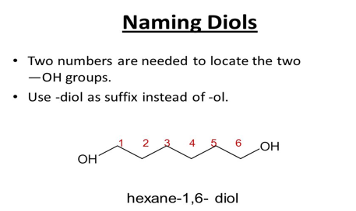

Instead of hexan-1-ol we have

hexane-1,6-diol

the “e” is left on in diols and diamines

**Diamine**

Skeletal formula of putrescineThey can be named similarly to diols.

For example: Instead of butane-1-amine, we get butane-1,4-diamine

**Dicarboxylic acids**

Just add -dioic instead of -oic. (Numbers are not required as carboxyl groups are always on terminal carbons). For example:

|  |  |
| --- | --- |
| propanedioic acid | [Malonic acid structure.png](https://en.wikipedia.org/wiki/File:Malonic_acid_structure.png) |
| butanedioic acid | [Succinic acid.png](https://en.wikipedia.org/wiki/File:Succinic_acid.png) |
| pentanedioic acid | [Glutaric acid.png](https://en.wikipedia.org/wiki/File:Glutaric_acid.png) |

**benzenecarboxylic / benzenedicarboxylic acid**

The systematic name for the series of compounds consisting of a benzene ring attached to one or two carboxyl groups/s.

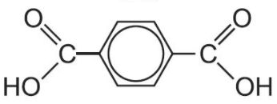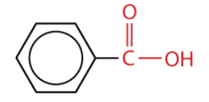

benzene-1,4-dicarboxylic acid

benzenecarboxylic acid

**The Phenyl Group (extension)**

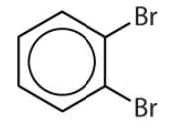Just as methyl is a methane with hydrogen removed, a phenyl is a benzene with a hydrogen removed. Phenyl is used when a benzene like structure replaces a hydrogen in another molecule.

In general, the use of benzene or phenyl depends on what the main parent chain of the compound is. If it's benzene with substituents, then it should be named using benzene, for example 1,2-dibromobenzene.  
  
However, if the benzene ring is merely a substituent on another "parent" chain, then you should use phenyl

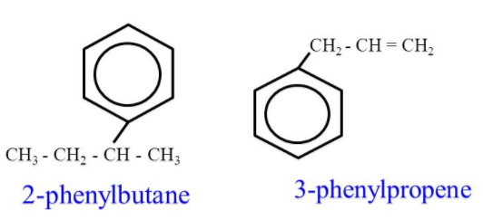

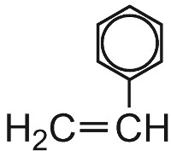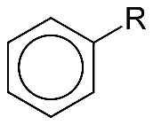

Phenyl

phenylethene

(Previously styrene)